Resourceful Computing Advances Chemistry at Caltech
March 07, 2014

In the 21st century, it seems impossible to imagine a group of researchers sharing just one computer. However, several decades ago—when computers required big budgets and lots of space—this hypothetical scenario was just the day-to-day reality of research. In the early 1970s, Caltech researcher Aron Kuppermann—seeking an alternative to this often-crowded arrangement—found additional computer resources in an unlikely place: a local religious organization. In the same spirit of creativity, Caltech researchers today have also found ways to practice resourceful computing.
Kuppermann's work focused on understanding how chemical reactions are influenced by quantum effects—the physics that governs the behavior of matter at the atomic (and subatomic) scale. Such quantum effects can now be studied in parallel with the Newtonian physics of a reaction using so-called "multiscale models," the development of which earned Caltech alum Martin Karplus (PhD '54) a share of the 2013 Nobel Prize in Chemistry. However, four decades ago, this "shortcut" wasn't available to Kuppermann, who passed away in 2011.
In the late 1960s and early 1970s, the quantum effects of these reactions were unknown territory," says George Schatz (PhD, '76), professor of chemistry at Northwestern University and a former student of Kuppermann's. "And in order to do these studies, one needed to do large, computationally expensive calculations that would simulate the chemical reaction using quantum mechanics."
Although Caltech had a computer center at the time and Kuppermann's group also had access to the supercomputer at Lawrence Berkeley National Laboratory via ARPANET, a precursor to the Internet, the shared equipment was in high demand, and individual research groups had limited time available for their calculations. "We were also limited as to how much we could accomplish because we were charged hundreds of dollars per hour to use a computer—and Kuppermann's research grant didn't have enough money to pay for what we needed," Schatz says.
Kuppermann and his colleagues knew that these computer resources would not be sufficient for their project, so they actively started looking for solutions. The answer was provided by a postdoctoral scholar who uncovered a wealth of unused computer time at a Pasadena religious organization called the Worldwide Church of God. The church and its associated religious school, Ambassador College, used an IBM 360 computer to record information about their donors —the same type of machine that Kuppermann's group was using at the Caltech's computer center. Such machines required that each line of computer code be physically "punched" out on a card, which would then be fed into and read by the computer.
The computer at Ambassador College was only used for church business during the week, so Kuppermann's lab group got permission to use the computer for research purposes on the weekends. "We would take these boxes of computer cards and either drive or ride our bicycles to Ambassador College," Schatz recalls. "When it started, we were doing this on Fridays—we'd prepare these cards, deliver them on Friday afternoon, and then go back on Monday to pick up the results. And since the computers were sitting idle over the weekend except for our work, we were actually able to accomplish a huge amount."
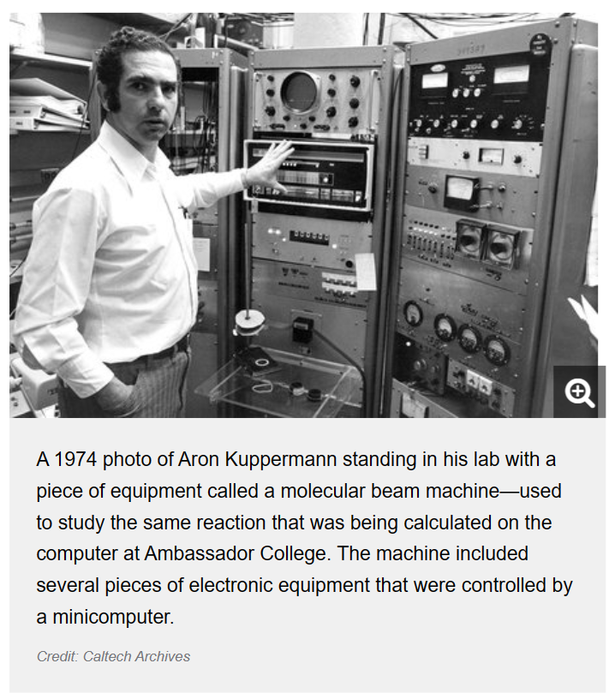
In fact, this unorthodox collaboration between a religious organization and a group of scientists enabled the Kuppermann group to resolve several important issues about the importance of quantum effects in chemical reactions. "These calculations allowed us to to solve the Schrödinger equation—in other words, to use quantum mechanics to describe the reaction of a hydrogen atom and a hydrogen molecule (H₂)," he says. "And it was the first time that the Schrödinger equation was solved for this reaction," a highlight of Kuppermann's career, Schatz says.
Despite the importance of the computing time, the staff at Ambassador College "had no idea that their computer was basically the center of the universe for doing computations of reaction dynamics," says Schatz. "We acknowledged Ambassador College in our papers at the time, but they never charged us for anything; they just seemed to be interested in the fact that we could do fundamental science with computer resources that they just were never using.
Eventually, advances in technology and increased funding for research computer centers spelled the end for this unusual collaboration, and today computers can be found in every nook and cranny on campus. However, that doesn't mean Caltech scientists have stopped finding resourceful, creative solutions to their computing and research problems.
For example, last fall, Professor of Chemistry Thomas Miller used an event called a "hackathon"—an all-hands-on-deck marathon of continuous computer programming—to make the most of another resource: the human mind. Miller's research at Caltech, similar to Kuppermann's, focuses on developing new computational methods to better predict and understand chemical reactions. With the help of the two-day programming event, Miller and his research group were able to quickly make progress on the development of a new computational method for quantum chemistry that had previously only existed on paper.
"If I had asked only a single person in my group to program the new method, it would have taken a couple of weeks," says Miller. "But after two solid days and nights of programming as a group—and a lot of pizza and bagels—we had a working implementation of the new method, we had gained valuable insight into its advantages and limitations, and we had an improved understanding of how best to implement the new method in its final version."
Although nonstop programming sounds like a stressful way to spend 48 hours, Miller says that he was impressed with the success of the hackathon and how well his students and postdocs rose to the challenge. "Everyone in the group has a million things to get done for their own research projects and degree requirements, so a programming exercise that benefits the group more than any one individual could easily have been viewed as a burden," he says. "But everyone—myself included—seemed to enjoy the urgency of the tight deadline and the responsibility of delivering essential components for a larger mission."
The computers used by Miller's lab at Caltech today are much more powerful than those available at the Caltech computer center of Kuppermann's day, but the computations now performed by researchers have also rapidly increased in complexity. This means that sourcing computer time—in Miller's case, about 30 million computer hours per year—from a variety of different computational resources is still common practice. In addition to on-campus computing, Miller and many other researchers apply for large amounts of computer time from agencies like the National Science Foundation or the Department of Energy.
But while the availability of computer resources is an important piece of the puzzle, Miller says the real challenge is in obtaining the physical insight—and enough good ideas—to do the right calculation. "As any theorist will tell you, a big computer is no replacement for scientific insight and creativity," both of which are found in abundance at Caltech, he says.
WRITTEN BY
Jessica Stoller-Conrad

https://www.caltech.edu/about/news/resourceful-computing-advances-chemistry-caltech-42127

